Chana Masala – Alison Mountford

By Alison Mountford, contributing chef to RINewsToday.com

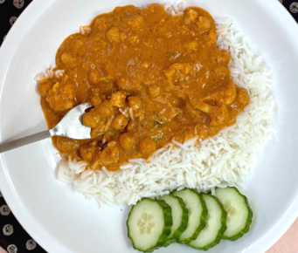

Three cheers for homemade Chana Masala! It’s so much fun to combine these spices and a few other ingredients and watch them meld into a crave-able and warming dish. We sometimes stir in some extra veggies, but you do you! Double and freeze half for a perfect freezer meal.

INGREDIENTS -
1 yellow onion
6 clove garlic
2 Tablespoon fresh ginger
1 serrano chile
3 Tablespoon canola oil
1 Tablespoon ground cumin
1 teaspoon kosher salt
1 Tablespoon ground coriander
1 teaspoon chili powder
1 teaspoon turmeric (ground)
1 teaspoon garam masala
1 28-ounce can crushed tomatoes
1 teaspoon white sugar
Juice of ½ - 1 lemon, to taste
2 15-ounce can garbanzo beans (not drained)
3 Tablespoons unsalted butter

INSTRUCTIONS
Chop the onion, garlic, ginger, and serrano as finely as you can. You can even use a small blender or food processor. Heat a large pot over medium heat. Add oil, onion mixture, and ½ teaspoon salt. Sauté for about 10 minutes, stirring frequently and turning down the heat if they start to brown.

Combine and add the spices: 1 Tablespoon ground cumin, 1 Tablespoon ground coriander, 1 teaspoon chili powder, 1 teaspoon ground turmeric, 1 teaspoon garam masala. Stir to cook for about 1 minute and let the fragrance bloom in the oil and heat.

Now, add the crushed tomatoes, sugar, lemon juice. Add the garbanzo beans including the liquid they come in and add ½ cup water. You’re looking for a soup consistency at this point, but it will cook down into more of a stew.

Increase heat to medium high until it reaches a rolling simmer, then reduce heat to medium-low and maintain a simmer (uncovered) for 15 minutes, or until thick and stew-like. Stir occasionally. Melt in 3 Tablespoons of butter to finish.

Serve over rice or with naan.

