Buffalo Brussels Sprouts with Blue Cheese Sauce – Alison Mountford

By Alison Mountford, contributing chef for RINewsToday.com

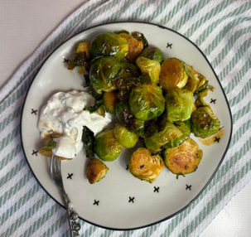

Active Time - 20
Total Time - 20

ABOUT - Vegetarians rejoice! Buffalo has come for everyone’s favorite fall vegetable, and you’ll never miss the chicken. We like to serve with blue cheese sauce and either toothpicks for an appetizer or just as a side dish.

INGREDIENTS
1 pound brussels sprouts
½ teaspoon kosher salt
1 teaspoon extra virgin olive oil

Buffalo Sauce
5 Tablespoons butter
5 Tablespoons hot sauce, like Frank’s or Tapatillo
1/2 teaspoon Worcestershire sauce
1/2 teaspoon honey

Blue Cheese Sauce
¼ cup mayo
¼ cup plain Greek yogurt
3 ounces blue cheese
1 teaspoon dried chives

COOKING INSTRUCTIONS
PREHEAT THE OVEN TO 400 degrees

BRUSSELS
Trim the ends off the brussels sprouts and cut in them half.

Toss on a baking sheet with the olive oil and salt. Make sure to include all of the leaves that fell off too - they’re the best part! Place in the oven and roast for about 20 minutes or until they’re tender but not soggy and the leaves and edges are getting nice and golden brown and crispy. Transfer to a large bowl.

BUFFALO SAUCE
While the brussels are roasting, make the sauce.
In a small pot over medium heat, melt the butter. When it starts bubbling, turn off the heat and whisk in the hot sauce, Worcestershire sauce, and honey all at once. Whisk well to combine and emulsify into a smooth sauce.

Pour the sauce over the cooked brussels, and toss to evenly coat.

BLUE CHEESE
In a small bowl, whisk together the mayo, yogurt, chives, and the blue cheese.
Serve the glazed brussels sprouts with a drizzle of sauce or with toothpicks and use the sauce as a dip.

