Apple Pie Bars with Salted Dulce De Leche – Alison Mountford

By Alison Mountford, contributing chef, for RINewsToday.com

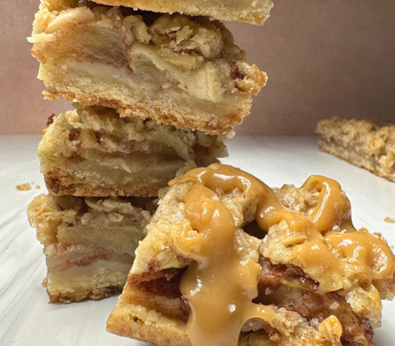

ABOUT - The dulce de leche drizzle is optional but worth every minute! You can spoon the leftovers on ice cream or dip in pretzels or short bread cookies later. It will last a few weeks in the fridge once transferred to a Tupperware.

** Make sure the can remains fully submerged by at least 2 inches of water. If the can is not fully submerged, it can overheat, tear, and even explode. Also, never try to open a hot can of dulce de leche. Wait until the can has cooled to room temperature before opening it; this can take about 4 hours!

DULCE DE LECHE
1 (14-ounce) can sweetened condensed milk, label removed
1/4 teaspoon Maldon Sea salt, plus optional, more for garnish

CRUST
- 1/2 cup unsalted butter, melted
- 1/4 cup sugar
- 1 teaspoon quality vanilla extract
- 1/4 teaspoon salt
- 1 cup all-purpose flour

FILLING
- 2 large apples, peeled and thinly sliced (1/4 inch thick)
- 2 Tablespoons all-purpose flour
- 2 Tablespoons sugar
- 1 teaspoon ground cinnamon
- 1/8 teaspoon freshly ground nutmeg

STREUSEL
- 1/2 cup old-fashioned oats
- 1/3 cup packed brown sugar
- 1/4 teaspoon ground cinnamon
- 1/4 cup all-purpose flour
- 1/4 cup unsalted butter, cold and cubed

Instructions

- Dulce De Leche - Place the can on its side in a large pot. Fill pot with room-temperature water, making sure water level is at least 4 inches above can! Remember, it's vital the can remain fully submerged during the entirety of simmering to prevent it from warping, splitting, or exploding.

- Set pot over high heat and bring to a simmer. Reduce heat and simmer for 2 hours for light, golden caramel, and up to 3 hours for dark, robust caramel; Set a time to check the pot every 30 minutes to ensure water level stays above can, adding boiling water as necessary to keep can under 2 inches of water.

- Use a pair of tongs to remove can from water and set on wire rack to cool to room temperature. Do not attempt to open can while still hot; this can cause pressurized hot caramel to spray dangerously. When can is completely cool, open and scoop out into a glass bowl; reheat in short bursts in the microwave until you have a drizzle-able consistency, stir in salt.

- BARS -
- Preheat the oven to 300°F. Line the bottom and sides of an 8-inch square baking pan with parchment paper leaving enough overhang on all sides. Set aside.

- Make the crust: Stir the melted butter, granulated sugar, vanilla, and salt together in a medium bowl. Add the flour and stir until everything is combined. Press the mixture evenly into the prepared baking pan. Bake for 15 minutes and then remove from the oven. (As the crust bakes, you can prepare the filling and streusel.)

- Make the apple filling: Combine the sliced apples, flour, granulated sugar, cinnamon, and nutmeg together in a large bowl until all of the apples are evenly coated. Set aside.

- Make the streusel: Whisk the oats, brown sugar, cinnamon, and flour together in a medium bowl. Cut in the chilled butter with your clean fingers or two forks until the mixture resembles coarse crumbs. Set aside.

- Bake -
- Turn the oven up to 350°F . Evenly layer the apples on top of the warm crust. It will look like there are too many apple slices, so layer them tightly and press them down to fit. Sprinkle the apple layer with streusel and bake for 30–35 minutes or until the streusel is golden brown.

- Remove from the oven and allow to cool for at least 20 minutes at room temperature, then chill in the refrigerator for at least 2 hours (or overnight). Lift the foil or parchment out of the pan using the overhang on the sides and cut into 12 or 16 bars. Once cut, rewarm the dulce de leche and drizzle some on top of each. Optional, sprinkle with a pinch more salt. These apple pie bars can be enjoyed warm, at room temperature, or even cold.

